TENTH WORKING GROUP MEETING OF AERONAUTICAL TELECOMMUNICATION NETWORK IMPLEMENTATION CO-ORDINATION GROUP (ATNICG WG/10)
Jaipur, India, 26 - 29 September 2011
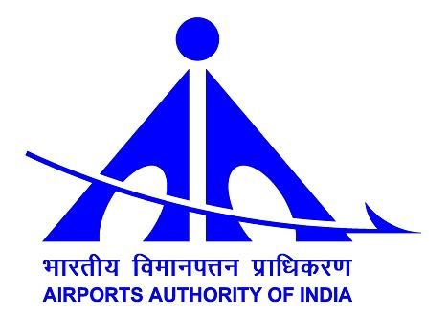

Agenda Item xx:

TITLE/SUBJECT TO BE PRSENTED
(Presented by State and/or Administration)
SUMMARY

1. INTRODUCTION
1.1 Text……………………………………………………………………………………
1.2 Text……………………………………………………………………………………
2. DISCUSSION
2.1 Text……………………………………………………………………………………..
2.2 Text……………………………………………………………………………………..
3. ACTION TAKEN BY THE MEETING
3.1 Text……………………………………………………………………………………..
3.2 Text……………………………………………………………………………………..

_ _ _ _ _ _ _ _ _ _ _ _

ATTACHMENT A

ATTACHMENT B

ATTACHMENT C

